**Chapter 3**

**How to use the software**

**Launching the software**

After successfully installing, we run the app from Start menu and then from coreCodes folder select cactus (PS).exe.

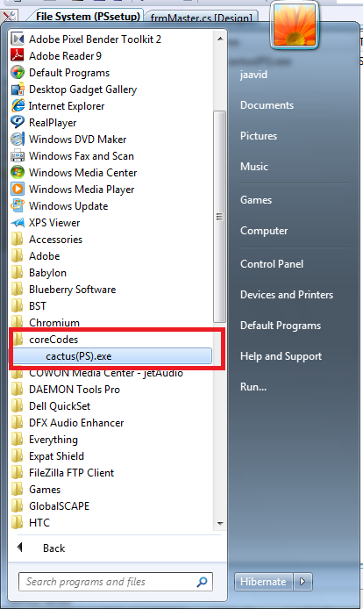

Figure 3-1 Launching the software

By selecting this file if installation was successful, application will show up.

**Logging in**

In this form all accounts are observable. By selecting our specific user account avatar or entering user name in the textbox, in case of having password we will enter the application.

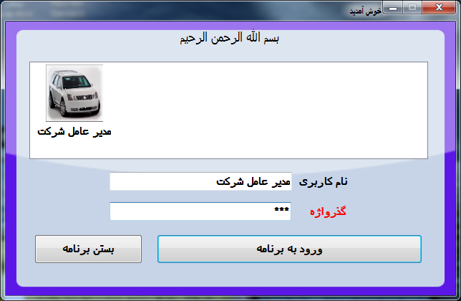

Figure 3-2 Logging in the software

**Note: Default password is 189.**

**After logging in, main window will be like figure 3-3.**

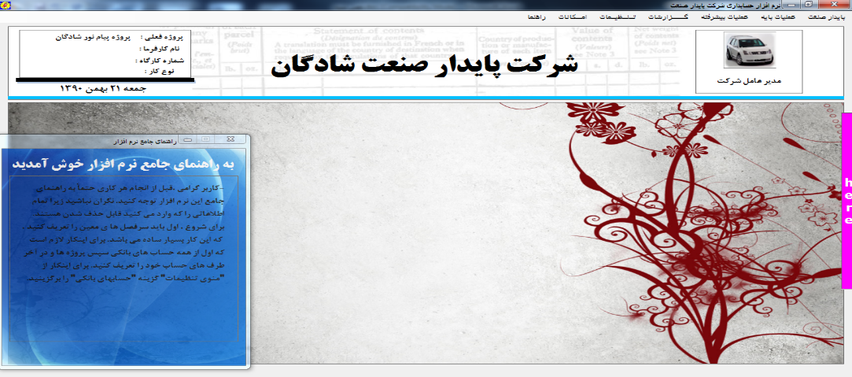

Figure 3-3 Main window

**Projects Management**

In this dialog box we can define current/future projects. (Figure 3-4)

To define a new project, you must click on the new project button and then enter the name of the project in the text box and confirm. In this form, you can enter other project attributes such as employer name, workshop number, type of work and project description.

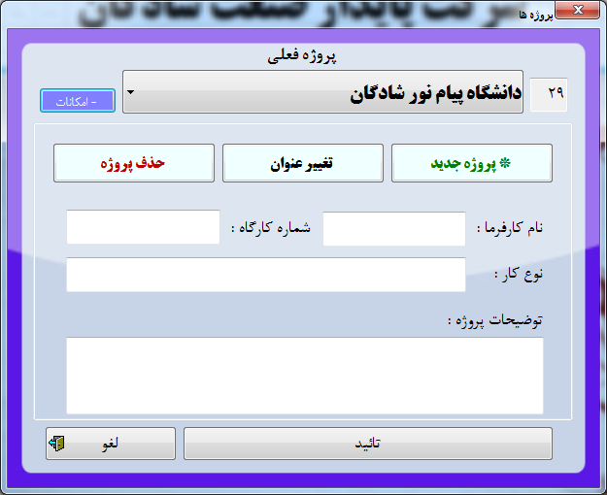

Figure 3-4 Project Management Dialog box

To determine the active project, select the desired project name from the drop-down list and click the confirm button.

**Persons Management**

After defining the projects, it is the time to define the Persons (account parties). To define the account parties, select the "Account parties" option from the "Basic Operation Menu". (Figure 3-5)

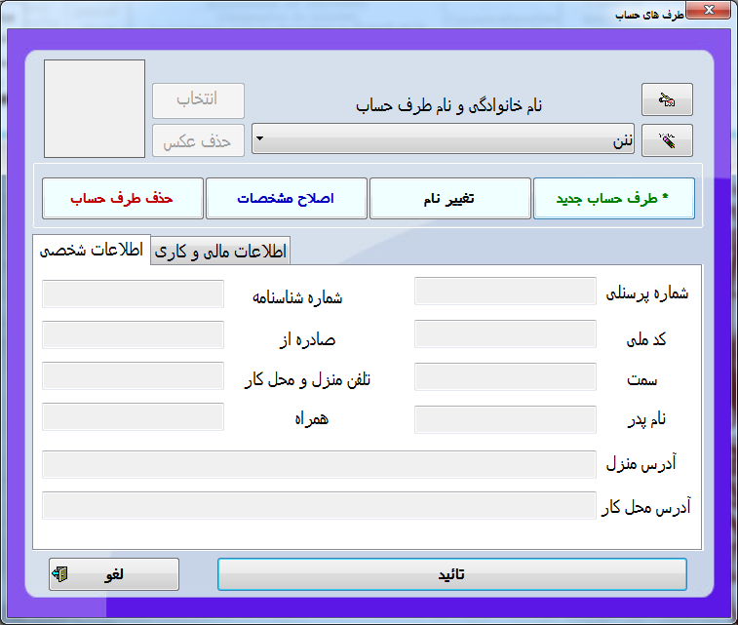

Figure 3-5 Persons

In the box that appears, click on the option of the new account party. Now first enter the last name and then the name of the account party and confirm it.

You will see that the name of the account party has appeared in the drop-down list. You can enter other details of the account side and click on the button to register changes. Click the confirmation button to close the account parties’ definition box.

**Form for displaying accounting books**

Now you've learned all you need to get started, and all the certain headings have created automatically. To view them, you can select "Subsidiary ledger" from the "reports menu". (Figure 3-6)

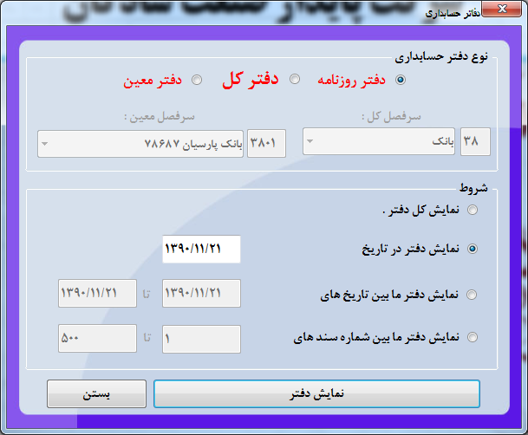

Figure 3-6 Accounting Books

Now click on the specific heading drop-down list to see the list of specific headings. After viewing the list, close the box.**Bank account management form**

Select "Bank Accounts" from the "Settings Menu". In the box that appears, click on the "*New Account" button and enter your account number in the box that will appear and confirm it. (Figure 4-7)

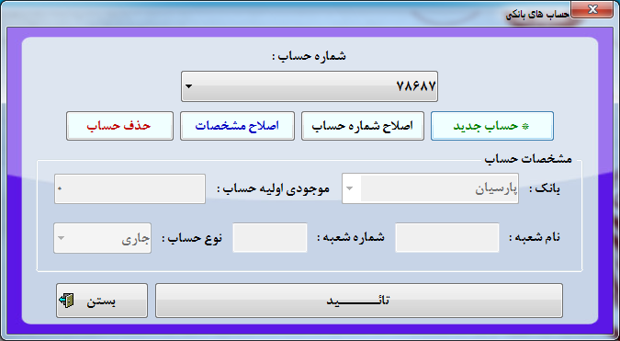

Figure 3-6 Bank Accounts Management

Then close the form. (If the name of the bank is not in the list of banks, introduce it to the app by writing the name of the desired bank in the desired place).